Exercise 5-2

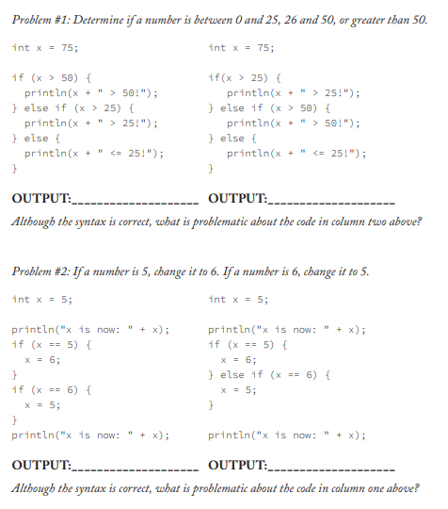

1. 75 > 50!
2. 75 > 25!
   1. The problem with the code is, that the second statement will never get run. Because the first statement will always be true if x is above 25, and the full statement will therefore end after executing the first statement and never get to statement two.
   2. x is now: 5
   3. x is now: 5
   4. The result will always be 5.
   5. x is now: 5
   6. x is now: 6